Contents

1 🔧What’s New 2

2 🚀 Fixed Defects 2

2.1 Known Issues: 4

3 ⭐ Improvements 5

3.1 CMS 5

3.2 CRM 5

4 🚀 Deployments 5

4.1 Infrastructure 5

4.2 CRM 7

4.3 CDN 7

4.4 Platform APIs 7

4.5 Web Apps 7

4.6 APIM 7

4.7 Mobile 8

4.8 B2C Tenant Policy Files 8

4.9 Data Resources 8

5 💻 Reviewers 8

6 Appendix 9

6.1 Running Pipeline from Tags 9

Release Note

# 🔧What’s New

New user stories delivered: **None**

| **ID** | **Title** | **State** |
| --- | --- | --- |
| [19269](https://dev.azure.com/TASMUCP/TASMU%20Central%20Platform/_workitems/edit/19269) | As platform operator i need to update all TASMU logos used in Report/Dashboard to reflect the latest update of the logo shared by TASMU | **Test Complete** |

# 🚀 Fixed Defects

The following bugs reported in SIT are addressed in the current interim build –

| **ID** | **Title** | **Severity** |
| --- | --- | --- |
| [33000](https://dev.azure.com/TASMUCP/TASMU%20MSI/_workitems/edit/33000) | FN - B2B Marketplace - Sf - When clicked on profile icon only Logout option is displayed. | 2 - High |
| [33158](https://dev.azure.com/TASMUCP/TASMU%20MSI/_workitems/edit/33158) | FN-B2C- User is not able to see profile details when logged in with Facebook credentials | 3 - Medium |
| [34007](https://dev.azure.com/TASMUCP/TASMU%20MSI/_workitems/edit/34007) | FUNC-B2B-B2C- Only Authorized user can subscribe to product as per target customer segment Failed | 2 - High |
| [34142](https://dev.azure.com/TASMUCP/TASMU%20MSI/_workitems/edit/34142) | NF-My TASMU App - iOS - The hero boxes are not rendering properly | 3 - Medium |
| [34158](https://dev.azure.com/TASMUCP/TASMU%20MSI/_workitems/edit/34158) | FN-My TASMU App Android- Confirm & Pay button is enabled even though Terms & Conditions and End User License Agreement checkboxes are unchecked | 4 - Low |
| [34165](https://dev.azure.com/TASMUCP/TASMU%20MSI/_workitems/edit/34165) | FN - iOS - "Products and Services" is not visible in Category drop-down for Create Support request | 3 - Medium |
| [34167](https://dev.azure.com/TASMUCP/TASMU%20MSI/_workitems/edit/34167) | FN-B2B Marketplace-Safari/Chrome - When user deletes an attached file, file dialogue opens | 3 - Medium |
| [34169](https://dev.azure.com/TASMUCP/TASMU%20MSI/_workitems/edit/34169) | NF-My TASMU App - iOS - Arabic- Back key label | 3 - Medium |
| [34217](https://dev.azure.com/TASMUCP/TASMU%20MSI/_workitems/edit/34217) | FN - My TASMU App - Android/ios- Error shown on clicking phone number in Contact Us page | 3 - Medium |
| [34228](https://dev.azure.com/TASMUCP/TASMU%20MSI/_workitems/edit/34228) | FN - My TASMU App - Android- User is able to enter Passport number without selecting Passport Country | 3 - Medium |
| [34230](https://dev.azure.com/TASMUCP/TASMU%20MSI/_workitems/edit/34230) | FN-SmartCity- User is not able to navigate between different sectors | 3 - Medium |
| [34244](https://dev.azure.com/TASMUCP/TASMU%20MSI/_workitems/edit/34244) | FN-Portal-Once user is logged out from profile page, user is still logged in on Home page. | 3 - Medium |
| [34247](https://dev.azure.com/TASMUCP/TASMU%20MSI/_workitems/edit/34247) | FN-B2B- Registration for Organization is not asked when Anonymous user raise a request from Chatbot | 2 - High |
| [34267](https://dev.azure.com/TASMUCP/TASMU%20MSI/_workitems/edit/34267) | FN-Portal-Expiry date of a subscription is not correct | 3 - Medium |
| [34295](https://dev.azure.com/TASMUCP/TASMU%20MSI/_workitems/edit/34295) | FN-B2B/B2C- Chatbot: Leave a message: User can't edit the message and email | 3 - Medium |
| [34296](https://dev.azure.com/TASMUCP/TASMU%20MSI/_workitems/edit/34296) | FN-B2C/B2B - User Profile: Address: Field length is 80 characters for City and 20 for PO Box | 3 - Medium |
| [34397](https://dev.azure.com/TASMUCP/TASMU%20MSI/_workitems/edit/34397) | FN-My TASMU App - iOS - Mobile app crashes after changing password from My Account section | 2 - High |
| [34399](https://dev.azure.com/TASMUCP/TASMU%20MSI/_workitems/edit/34399) | FN - My TASMU App Android- UI issue for linked accounts in Accounts page | 3 - Medium |
| [34413](https://dev.azure.com/TASMUCP/TASMU%20MSI/_workitems/edit/34413) | NF-My TASMU App - iOS - Arabic- Arabic Text is flipped in different places | 3 - Medium |
| [34448](https://dev.azure.com/TASMUCP/TASMU%20MSI/_workitems/edit/34448) | FN-My TASMU App- iOS - Mobile App crashes when login through LinkedIN | 1 - Critical |
| [34541](https://dev.azure.com/TASMUCP/TASMU%20MSI/_workitems/edit/34541) | FN-Portal-After user logs out, another user is able to access My account page of the user | 1 - Critical |

## Known Issues:

1. The localized content is being waited upon for approvals. As part of bug fix 34007, the below pop-ups were introduced.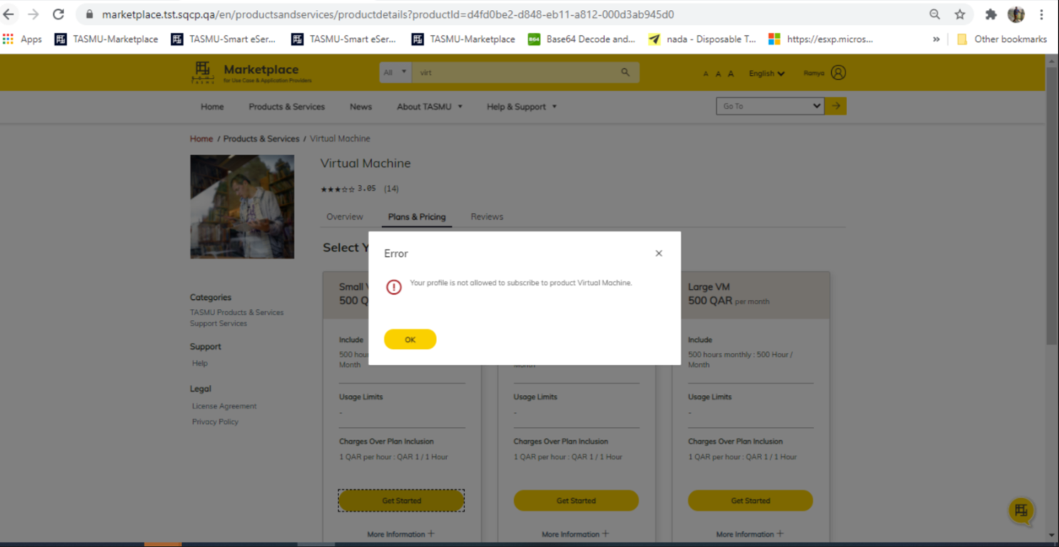
2. As part the bug fixes (33000, 33158) the below pop-ups are introduced. Waiting for the approved localized contents of the pop-up and KB articles. The content of the KB article is not approved however, the content of the pop-up is approved. 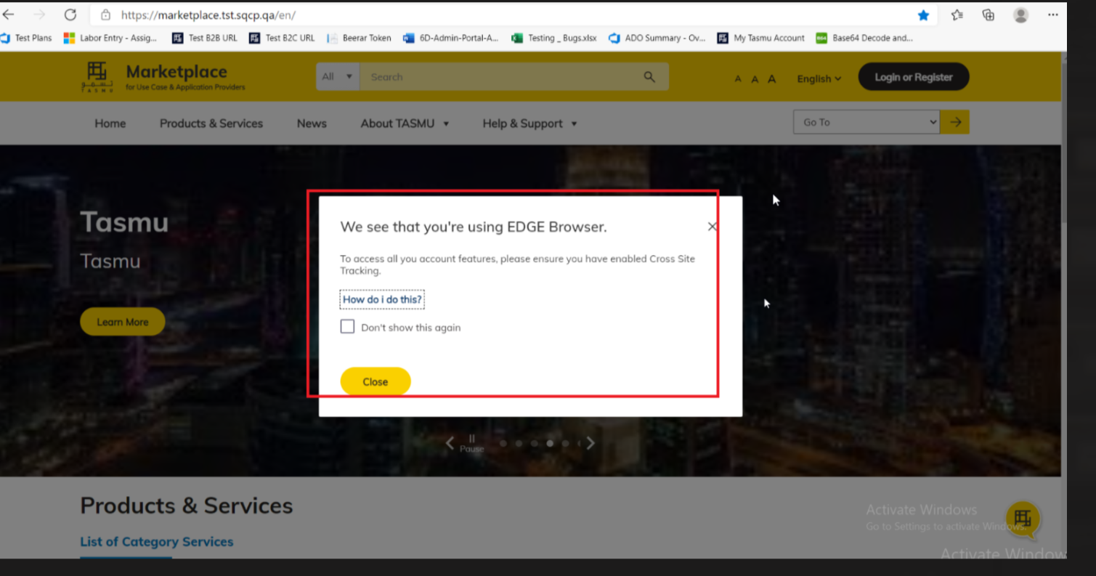
3. As part of the 34007, subscription of the products and services with the existing credentials, is not possible, as the profiles lack the customer segmentation. Hence accordingly the data should be configured in CRM system.

# ⭐ Improvements

## CMS

1. Waiting time of the trigger is decreased from 3 minutes to 1 minute so that approval process can be speeded up.
2. Sync Sector function app will be triggered for every 24 hours, which was 5 minutes earlier, so that load is reduced.
3. “Copy CDN URL” functionality has been introduced in all document/image library so that CDN URL for contents can be copied with ease, which will increase the Usability.

## CRM

1. Session affinity related setting change to compliment scale improvements being done at Dynamics (product) environment through support team.

**Further performance testing should be done only after this release, as well as additional environment preparation. For CRM, the environment type must be of ‘production’ (not ‘sandbox’), and dynamics web servers must be scaled out to minimum six servers to overcome API throttling (this can be done through product support request or ICM ticket). Both Platform APIs and CRM builds need to go for this performance improvement.**

# 🚀 Deployments

## Infrastructure

Pull Request – <https://dev.azure.com/TASMUCP/TASMU%20MSI/_git/infra/pullrequest/5668>

Steps:

1. Keep the backup of consumption container from below storage account:
   1. st<sub>globacmwe01
2. Delete the below storage account:
   1. st <sub>globacmwe01
3. Delete the following resources (if present) from azure portal -
   1. func-<sub>-apps-o365-<env>-we-01
   2. func-<sub>-apps-d365-<env>-we-01
4. Remove the following ARM template parameter files from **Modules/ARM/FunctionApps** -
   1. func-<sub>-apps-o365-<env>-we-01-parameters.json
   2. func-<sub>-apps-d365-<env>-we-01-parameters.json
5. Remove the deployment orchestration code for the function apps mentioned in **Step 2** from **DeploymentOrchestration/Environments/<sub>/<env>/rg-<sub>-apps-int-<env>-we-01/deploy.json**
6. Update the sku for StorageAccount - st<sub>globacmwe01 to Standard_ZRS
7. Update the following logic apps for new changes (UAT reference)
   1. logic-<sub>-apps-intaprv1-<env>-we-01-parameters.json
   2. logic- <sub> -apps-intgbaprl-<env> -we-01-parameters.json
   3. logic- <sub> -apps-inttrsl -<env> -we-01-parameters.json
8. Private end point implementation for sb-<sub>-apps-strntf-<env>-we-01
   1. Update vnet-<sub>-pltf-<env>-we-01 ARM template for adding service endpoints to subnets - snet-<sub>-apps-aks-<env>-we-01 and snet-<sub>-apps-bkend-<env>-we-01

,

{

"service": "Microsoft.ServiceBus",

"locations": [

"westeurope"

]

}

* 1. Add template for private dns zone - <sub>-privatelink.servicebus.windows.net
  2. Add it to deployment orchestration of rg-<sub>-pltf-net-<env>-we-01 (For CPD, the <env> here is dev as private dns zones is only created once in a subscription)
  3. Add parameter for private endpoint like prvep-<sub>-apps-sbstrntf-<env>-we-01
     1. PrivateDnsZoneId is resource Id of <sub>-privatelink.servicebus.windows.net
     2. Within two different environments, this resource Id of private dns zone will remain same.
  4. Add the private end point to deployment orchestration of rg-<sub>-apps-net-<env>-we-01
  5. Move and update the below parameter files of ServiceBusNamespace
     1. sb-<sub>-apps-strntf-<env>-we-01 (module version - 2021-03-18)
     2. Make the module version update in deployment orchestration as well.
  6. Add the CI pipeline for new module – CI-ServiceBusNamespace-20210318-Master-Build
  7. Rename the existing to CI-ServiceBusNamespace-20170401-Master-Build

1. Key Vault purge protection enabled for following key vaults:
   1. Create CI pipeline for new module -
      1. CI-KeyVault-20210323-Master-Build
      2. Rename existing to CI-KeyVault-20191128-Master-Build
   2. Move and update the below parameter files to 2021-03-23 and update deployment orchestration files as well. (refer UAT)

|  |  |  |  |  |
| --- | --- | --- | --- | --- |
| Key Vault | Soft Delete | Soft Delete Retention Days | Purge Protection | Remarks |
| kv-<sub>-apps-<env>-we-01 | true | 7 | true |  |
| kv-<sub>-apps-pt-<env>-we-01 | true | 7 | true |  |
| kv-<sub>-pltf-<env>-we-01 | true | 90 | true | Retention days were already set to 90 and can’t be changed now. |

1. Deploy the following resource groups:
   1. rg-<sub>-glob-acm-we-01
   2. Upload the containers content to st<sub>globacmwe01 (backup taken in step 1)
   3. Update the secret **ConnectionStrings-ConsumptionStorageAccount** in Key Vault (kv-<sub>-apps-<env>-we-01) with connection string of st<sub>globacmwe01
   4. rg-<sub>-pltf-net-<env>-we-01 (For CPD, the <env> here is dev as private dns zones are one per subscription)
   5. rg-<sub>-apps-net-<env>-we-01
   6. rg-<sub>-pltf-sec-<env>-we-01
   7. rg-<sub>-apps-sec-<env>-we-01
   8. rg-<sub>-apps-pt-<env>-we-01
   9. rg-<sub>-apps-str-<env>-we-01
   10. rg-<sub>-apps-int-<env>-we-01
2. kv-cpp-apps-pre-we-01 has an issue in pre prod environment with sqcp-ado-spn being greyed out in access policies. Check if it needs manual intervention after deployment. (work with support team on permanent resolution of this)

## CRM

|  |  |
| --- | --- |
| **Build Id** | **Pipeline Name** |
| 35772 | [CD-CrmPlatform-Release](https://dev.azure.com/TASMUCP/TASMU%20Central%20Platform/_build/results?buildId=35772&view=results) |

4.2.1 [Verify workflows are activated of deployment guide](https://dev.azure.com/TASMUCP/TASMU%20Central%20Platform/_wiki/wikis/TASMU-Central-Platform.wiki/137/Dynamics-365-Deployment-Guide)

Manual Steps for CRM:  
Two KB articles (One for english and other for Arabic) need to be created in the CRM environment and update the trackingId and trackingId_AR with respective article Ids in environment specific variable section of CD-WebApps-Release and CD-WebApps-Prd-Release (This is already done for pre)

## CDN

|  |  |
| --- | --- |
| **Tag** | **Pipeline Name** |
| SIT_CDN_25Mar2021 | [CD-CDNContainer-Prd-Release](https://dev.azure.com/TASMUCP/TASMU%20Central%20Platform/_build?definitionId=1019) |

## Platform APIs

|  |  |
| --- | --- |
| **Tag** | **Pipeline Name** |
| SIT_API_25Mar2021 | [CD-PlatformAPIs-Prd-Release](https://dev.azure.com/TASMUCP/TASMU%20Central%20Platform/_build?definitionId=1021) |

## Web Apps

|  |  |
| --- | --- |
| **Tag** | **Pipeline Name** |
| SIT_Web_25Mar2021 | [CD-WebApps-Prd-Release](https://dev.azure.com/TASMUCP/TASMU%20Central%20Platform/_build?definitionId=1020) |

## APIM

|  |  |  |
| --- | --- | --- |
| **Tag** | **APIs** | **Pipeline Name** |
| SIT_APIM_25Mar2021 | MarketplaceCatalogueApi; | [CI-APIMConfig-CentralPlatformCore-Master-Prd-Build](https://dev.azure.com/TASMUCP/TASMU%20Central%20Platform/_build?definitionId=1150) |
| SIT_APIM_25Mar2021 | MarketplaceCatalogueApi; | [CD-APIMConfig-pre-Release](https://dev.azure.com/TASMUCP/TASMU%20Central%20Platform/_build?definitionId=962) |

## Mobile

|  |  |  |
| --- | --- | --- |
| **Platform** | **Build Id** | **Pipeline Link** |
| Android | 35941 | <https://dev.azure.com/TASMUCP/TASMU%20Central%20Platform/_build/results?buildId=35941&view=results> |
| iOS | 35942 | <https://dev.azure.com/TASMUCP/TASMU%20Central%20Platform/_build/results?buildId=35942&view=results> |

## B2C Tenant Policy Files

1. Upload the policy files. Source – [Tag - SIT_Web_25Mar2021](https://dev.azure.com/TASMUCP/TASMU%20Central%20Platform/_git/web-apps?version=GTSIT_Web_25Mar2021)
   1. B2C_1A_B2B_TrustFrameworkBase_<env>.xml
   2. B2C_1A_B2B_TrustFrameworkExtensions_<env>.xml
   3. B2C_1A_BO_TrustFrameworkBase_<env>.xml
   4. B2C_1A_BO_TrustFrameworkExtensions_<env>.xml
   5. B2C_1A_TrustFrameworkBase_<env>.xml
   6. B2C_1A_TrustFrameworkExtensions_<env>.xml
   7. B2C_1A_TrustFrameworkBase_linking_<env>.xml
   8. B2C_1A_TrustFrameworkExtensions_linking_<env>.xml
2. Please apply any B2C policy customizations selectively done for pre prod environment. Eg: Disabling email verification check on registration.

## Data Resources

PowerBI reports have been amended and are to be used as samples by Malomatia to update the PowerBi reports in pre-production.

It is a manual deployment, requires download of pbix files, amending the data sources to consume it from pre-prod service, upload the pbix files into PowerBI service.

# 💻 Reviewers

|  |  |
| --- | --- |
| Prepared By | Manvir Kaur, Sumit Gupta, Sutan Dan |
| Company name | Microsoft |
| Reviewed by | Ravi Sankar Pillutla, Anil Erkek, Abhishek Ghosh, Subhajit Chatterjee, Gareeb Navas T M, Mecit Atmaca |
| Approved by | Ashwani Sharma |

# Appendix

## Running Pipeline from Tags

